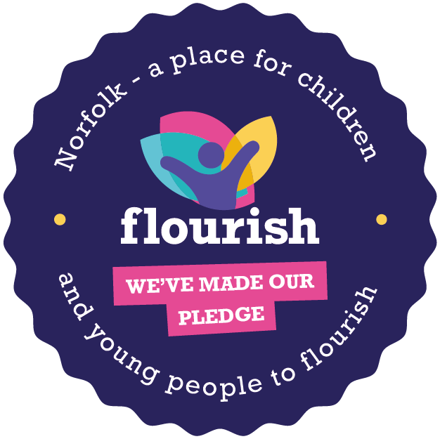



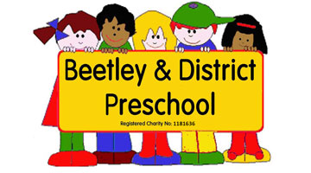
01362 860860 07736405862
office@beetley-preschool.org
www.beetley-preschool.org

THE MOBILE
STMARY’S SCHOOL
ELMHAM ROAD
BEETLEY
DEREHAM
NORFOLK NR20 4BW

Prospectus

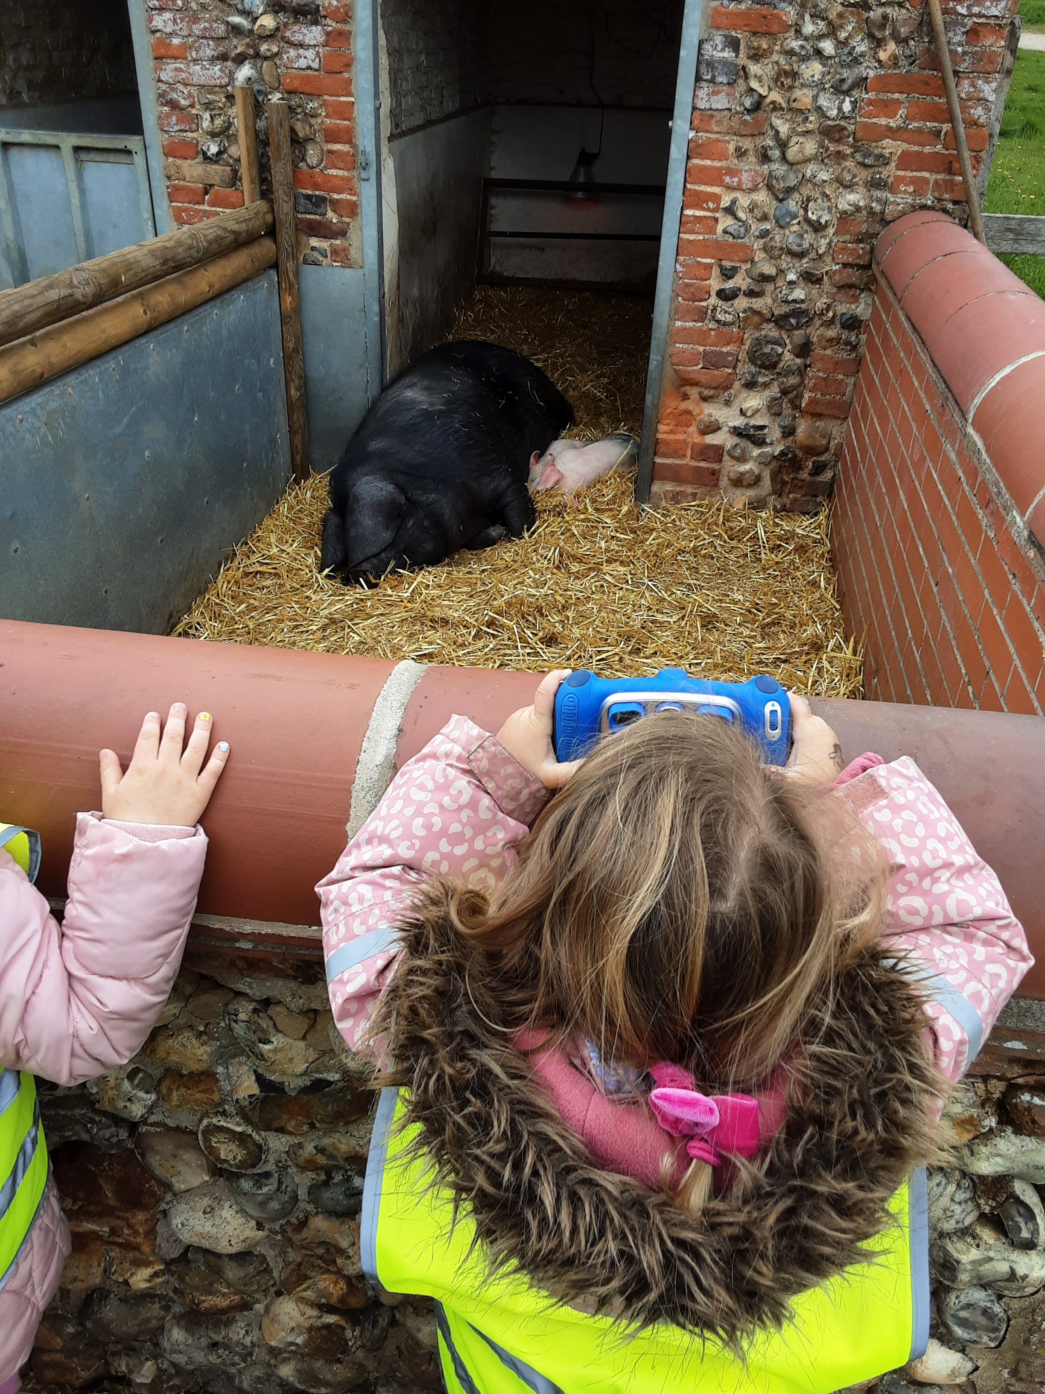
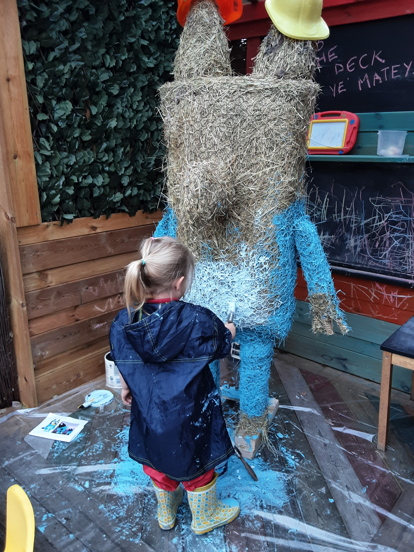
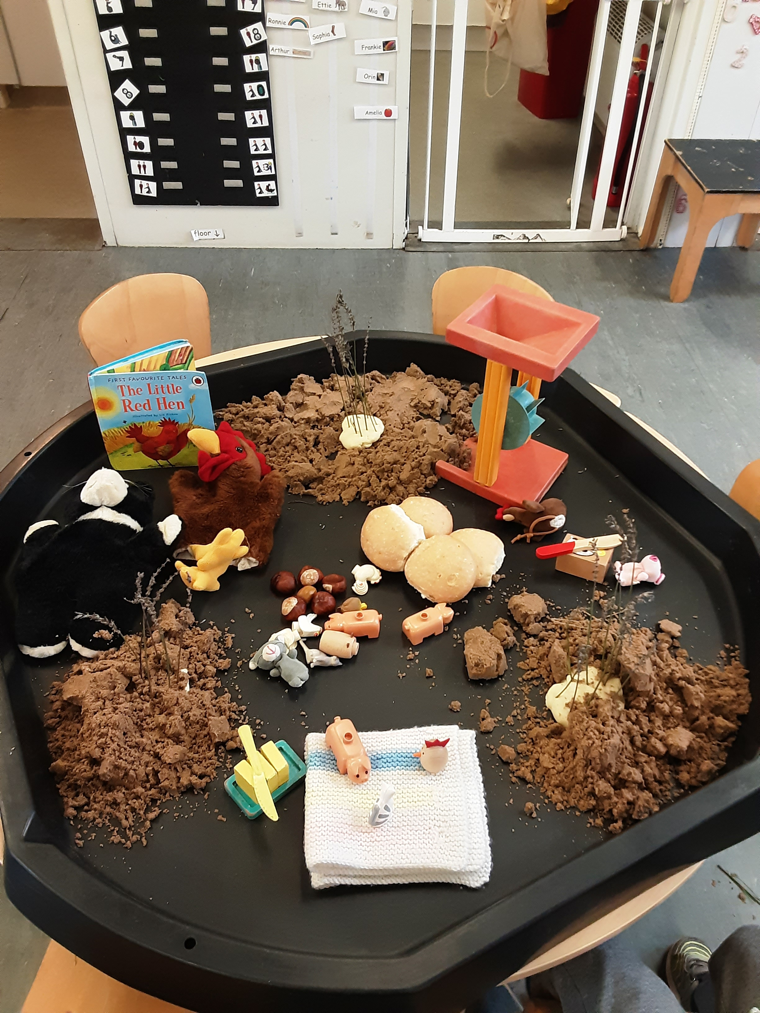
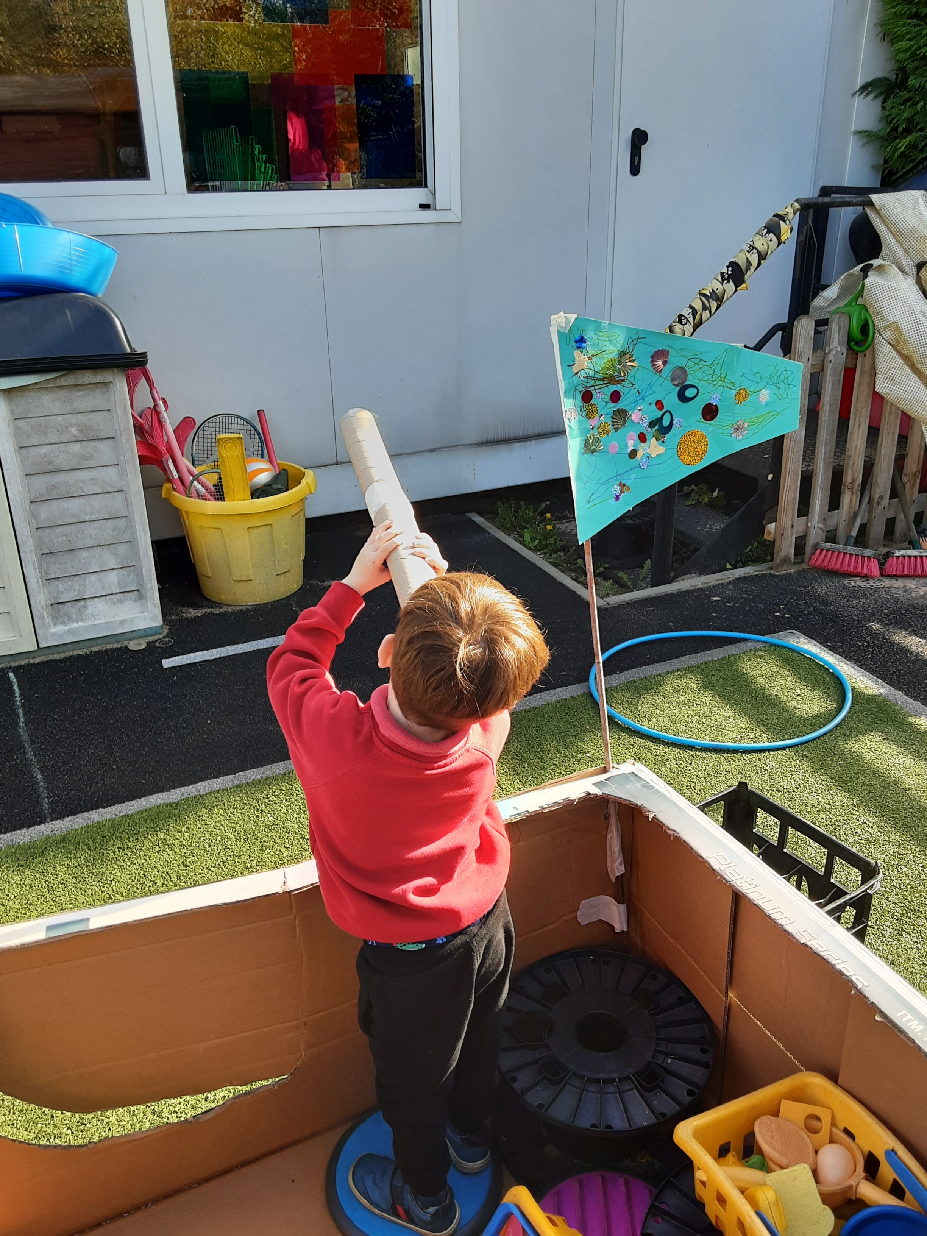
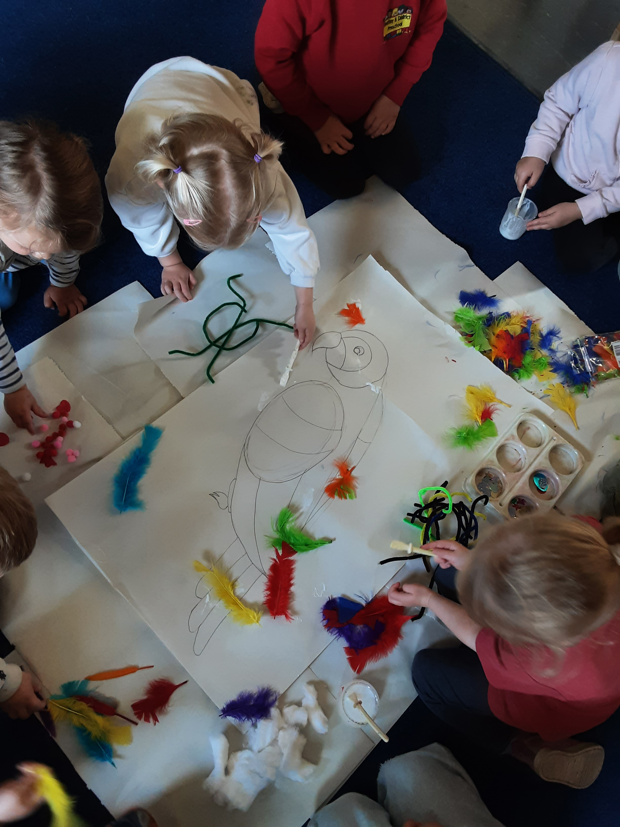
ABOUT US

Beetley & District Preschool
  - CHARITY NUMBER 1181636
Beetley & District Preschool is set within the grounds of St Mary’s Community Primary School in the village of Beetley, two miles from East Dereham in Norfolk. On the 22nd July 2020 we re-registered with Ofsted under a new charity number and at our latest inspection we achieved “good“.
The Preschool was established in 1971 and has played an active role in the community ever since then.
We believe that our children benefit most from early years education and care when we work in partnership with parents and carers. Our aim is to support you as your child’s first and most important educator by involving you in the full life of the preschool as much as possible.
The Preschool is a member of the Early Years Alliance, operating under its 2013 Constitution. We also have the Norfolk Quality Assurance Scheme approval.
The Preschool is a registered charity led by an active and enthusiastic voluntary management committee made up of parents and staff.

OUR AIM
- For all children to feel safe, secure and happy in a stimulating environment that fosters strong relationships with their key person, other practitioners and peers within the setting. To be confident, independent individuals who are excited and motivated to learn, building resilience to cope with changes to their normal everyday routines.
- Our staff will give your child comfort, a hug or cuddle, if they are distressed, hurt, worried, upset, or instigate the need for affection. Our aim is to treat your child as you would, if you were here – we realise the importance of re-assuring a distressed child. All our staff are DBS checked (Disclosure & Barring Service) and a minimum of 2 staff are present however few children attend sessions.
LEARNING THROUGH PLAY  We provide a warm, caring, stimulating setting in which children learn through play.  Our highly trained staff offer the Early Years Foundation Stage curriculum support, helping your child start to learn skills getting them ready for school.  Children enjoy imaginative free play, spending time in our indoor and outdoor areas throughout the day. Whether they’re a fan of the mud kitchen or cosy reading area, children can follow their needs and interests.  In our space, the children can plant flowers or vegetables, explore painting and drawing, build with various construction and engage in imaginative and creative areas.  We also engage in groups with activities such as baking, dance, rhymes and games.  When it rains or is cold you can still find us outside wrapped up against the elements, enjoying splashing in puddles, playing in the snow, or picking up the falling leaves.  Educational activities boost children’s communication and language, Personal social and emotional, and physical development, the 3 prime areas of learning. We offer individual support plans for children who need a little extra support. We are experienced in working in close liaison with professionals across the range of special needs. If you would like to discuss our ability to meet your child’s needs please see the manager or deputy. |  | 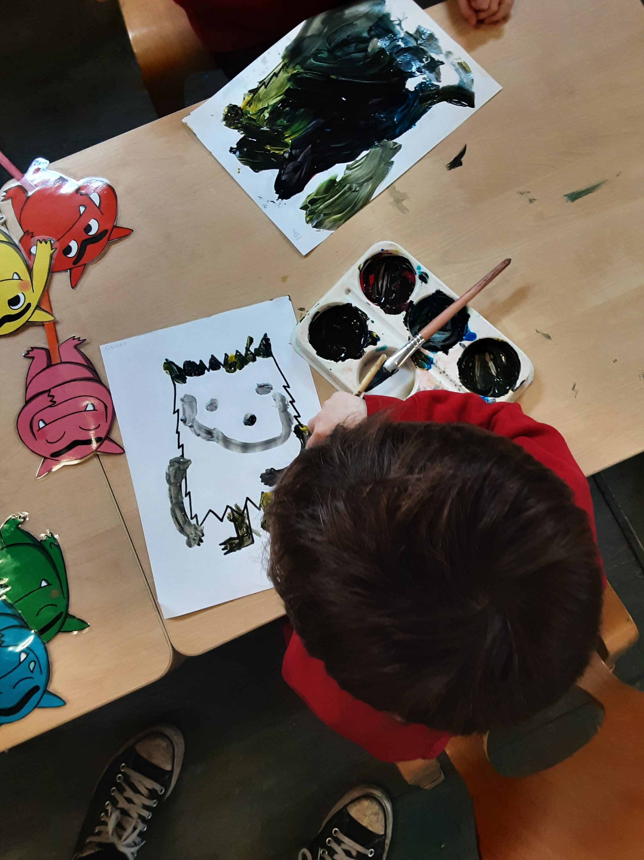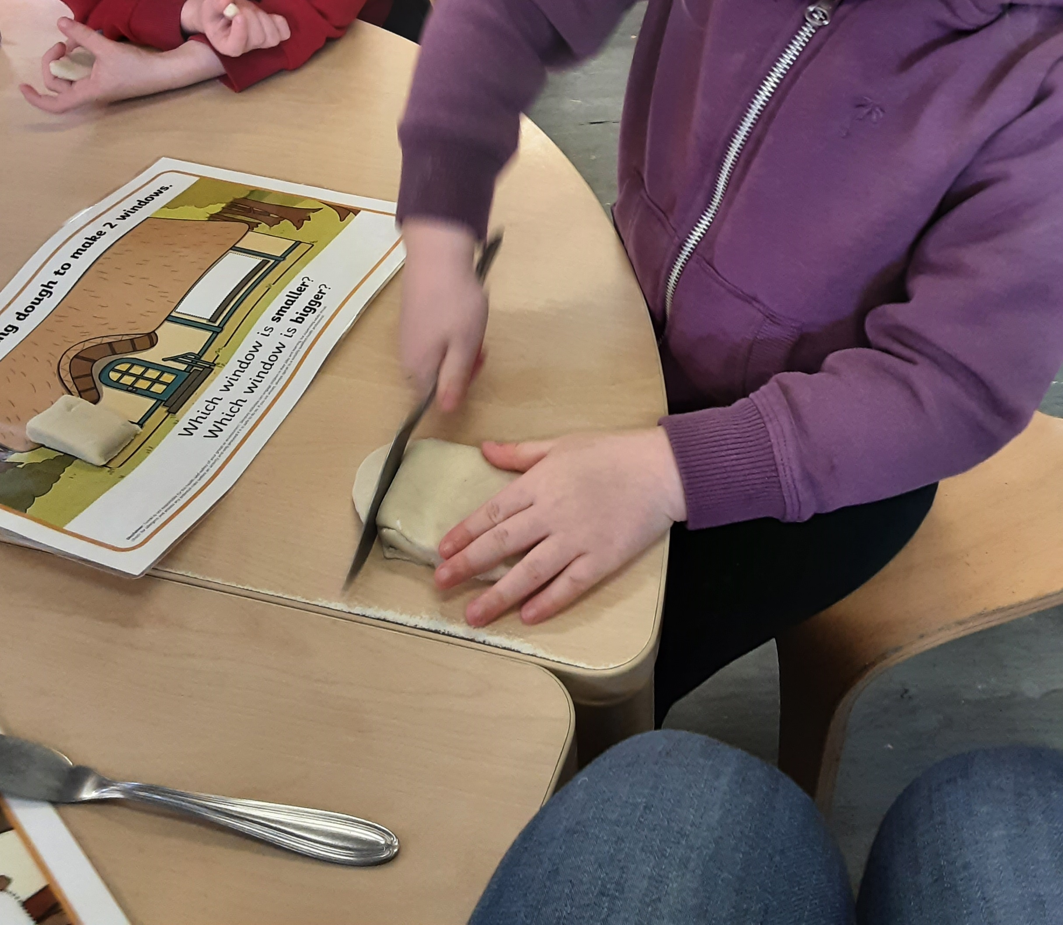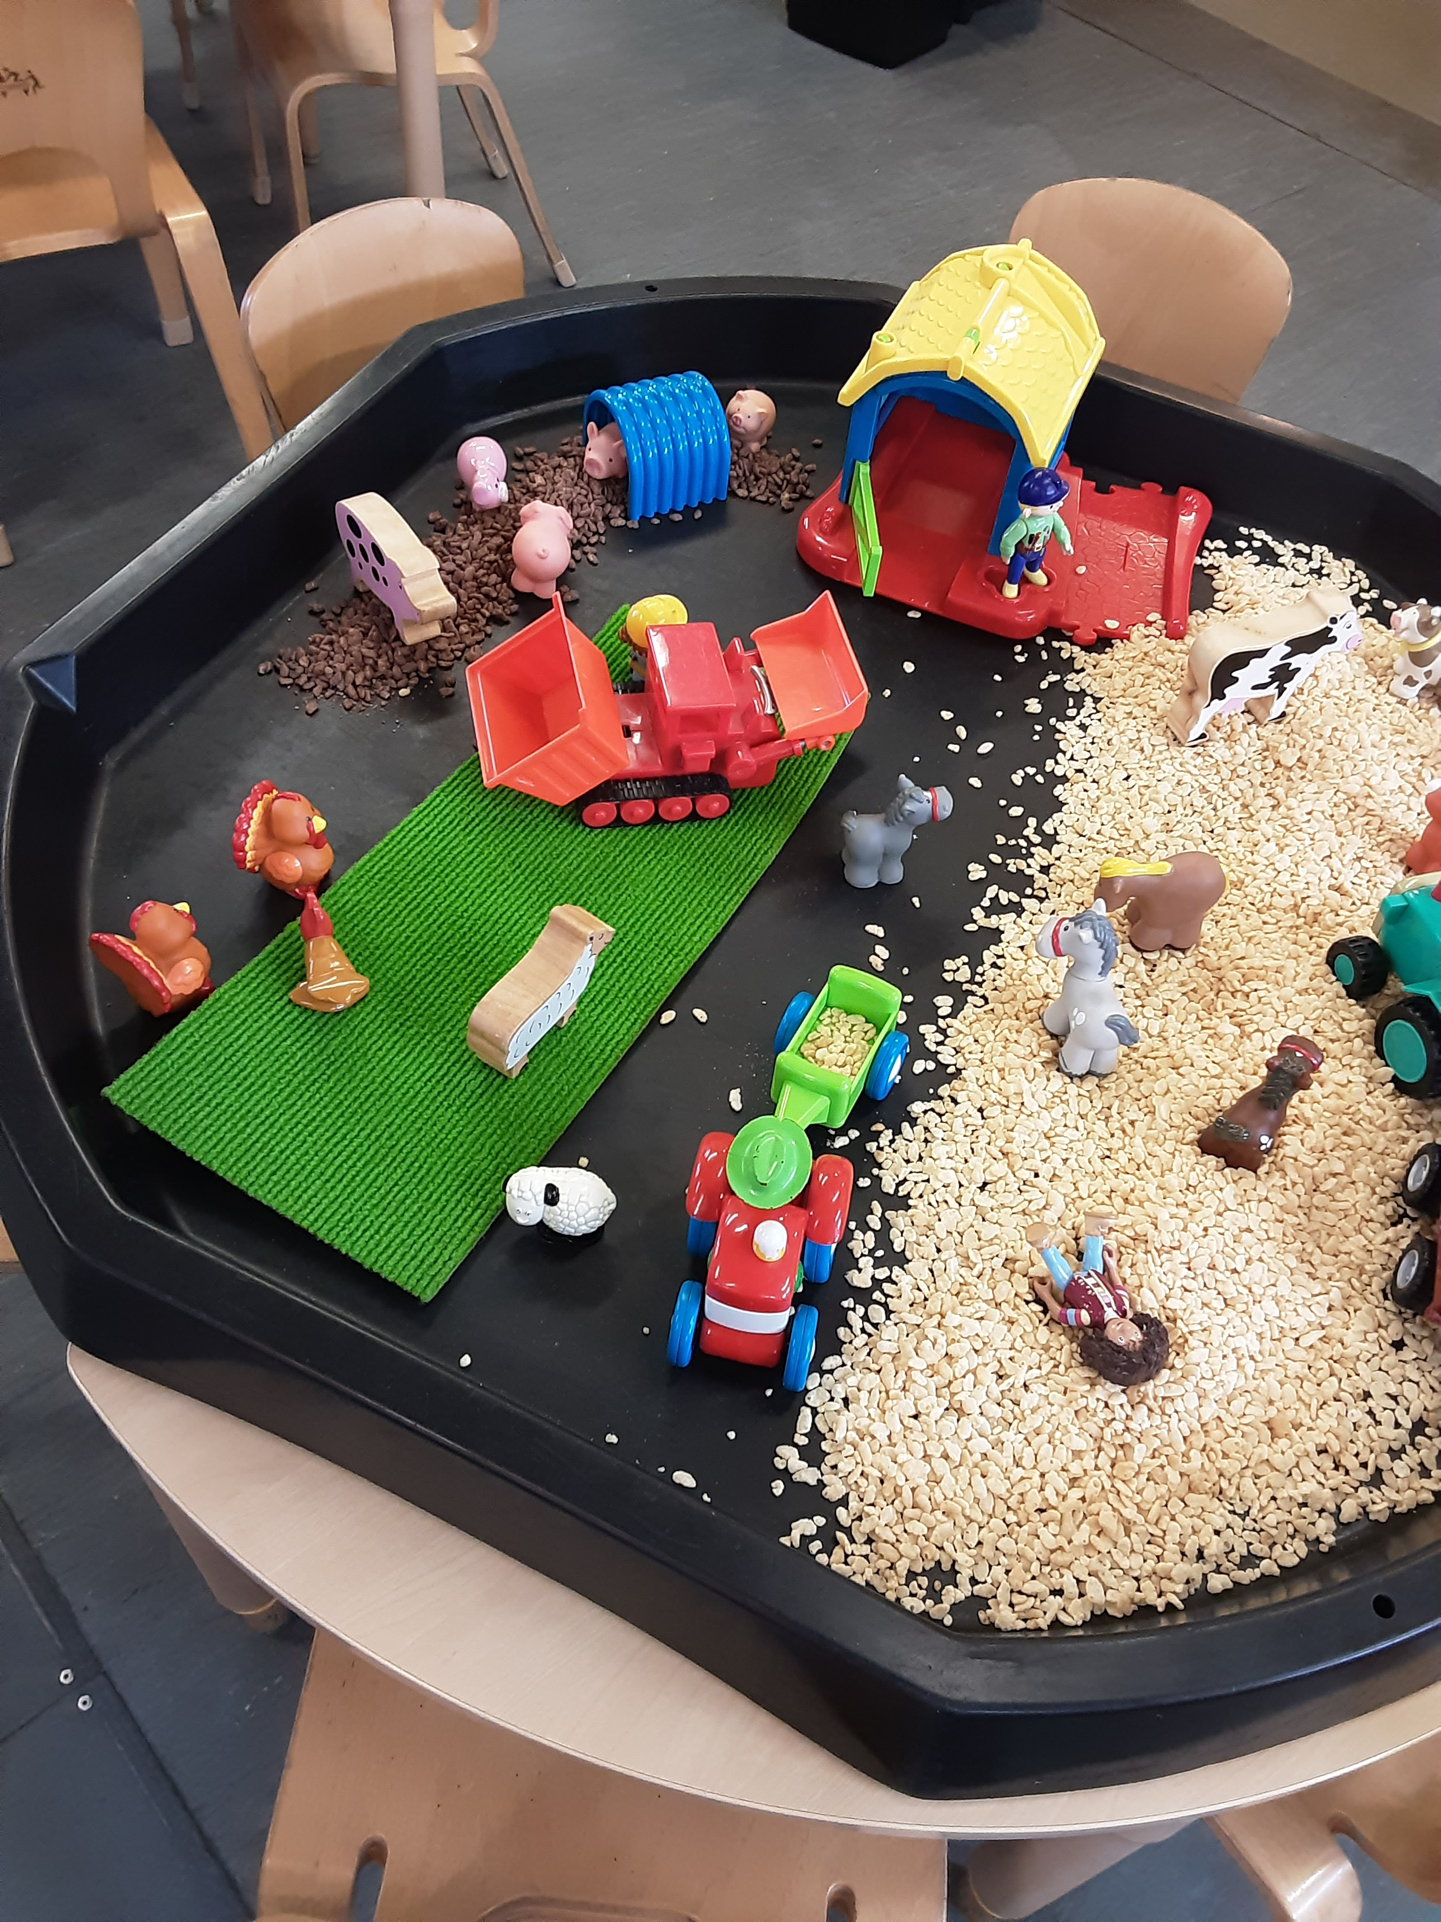

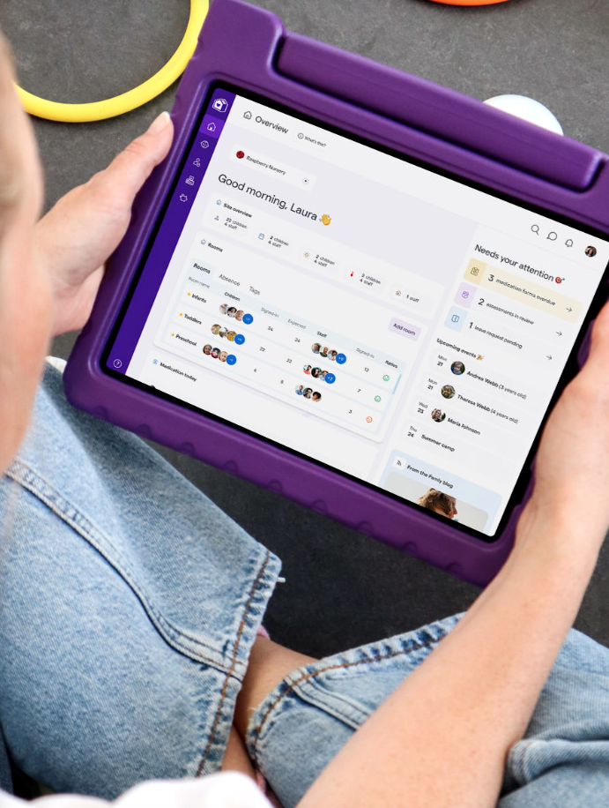 | KEEPING IN TOUCH  We use a platform called Famly for staff and families to collaborate and share knowledge. Families and educators can communicate through messages, learning journeys and assessments are shared, registers, accident forms, bills and daily logs are all stored in one place. It can be accessed by computer, laptop, Apple, tablets and smart phones.  Safeguarding of our children is very important to us and everything that is added to Famly will be added to our preschool account. This can only be viewed by preschool staff and parents who have been sent their own unique password. As a parent you will be able to add to their Learning Journal with information on things they do at home.  An invitation to access Famly will only be sent once parents have signed and agreed to our 'User Agreement', which is attached to the registration form.  Parents will only have access to their own child's learning journal.  Information and videos about Famly can be found at  https://famly.co/famly-together/

CURRICULUM
Within the group all children are supported in developing their potential at their own pace. Our key worker system enables us to ensure a planned curriculum tailored to the needs of each individual child. For our children we follow the Early Years Foundation Stage statutory framework. The EYFS framework is a government document that all schools and Ofsted-registered early years providers in England must follow. It sets standards for the learning, development and care of your child from birth to 5 years old. The standards ensure your child will learn and develop well and are kept healthy and safe.
The EYFS framework identifies the essential role of play in your child’s development. It is through both child-led play and play guided by an adult that your child will develop confidence and relationships with others. Through play, EYFS practitioners will help your child to extend their vocabulary and develop their communication skills.
The EYFS framework identifies three characteristics of effective teaching and learning:
playing and exploring active learning creating and thinking critically
Creating and thinking critically
Active Learning
Playing and Exploring

The EYFS framework outlines seven areas of learning and development and educational programmes. There are three prime areas of learning, which are particularly important for your child’s development and future learning:
There are four specific areas of learning, through which the prime areas are strengthened and applied:

There are four overarching principles in the Early Years Foundation Stage (EYFS).
Every child is unique and individual and will make progress at different rates. In order to thrive, learn and develop, they need to have opportunities to create positive relationships with others and explore environments that stimulate their curiosity.
These principles underpin all aspects of teaching and learning in the Early Years Foundation Stage.
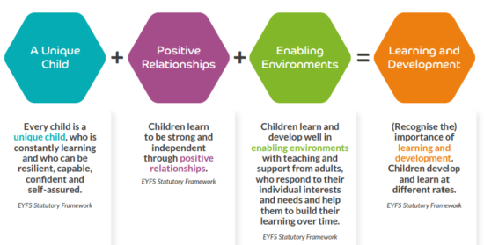

LEARNING JOURNEY
Your child’s Learning Journey celebrates their experiences. Over time it will tell a story about your child – their learning, friends, and the experiences they enjoy sharing with others.
Staff watch and notice each child at play because it helps us to understand and support their individual wellbeing and development. We really get to know the children as unique people with special skills, interests and ideas. The more we understand about the child, the better we can support them in the way that is right for them.
We work together to build this Learning Journal as a record of your child’s Early Years. We value parents and carers sharing in their child’s learning journey.

OUR TEAM
Our Manager, Miss Abigail Jenkins, and/or the Deputy Mrs Hollie Durrant, together with trained staff, manage each session. Training courses are regularly taken, thereby maintaining the high standards we demand. We are constantly in touch with new thinking in the field of childcare and education, and our staff have regular Supervision meetings. In addition, all staff are required to attend a paediatric first aid course and Introduction to Safeguarding.

We operate a Keyperson system, whereby each member of staff has a particular responsibility for a number of children. Your child's keyperson will build strong relationships with you and your child. They are your main point of contact within the setting and will help your child to become settled, happy and secure. They are responsible for sharing information with you with regards to their progress and give you ideas as to how you can help your child at home.

Miss Abigail Jenkins  Manager | 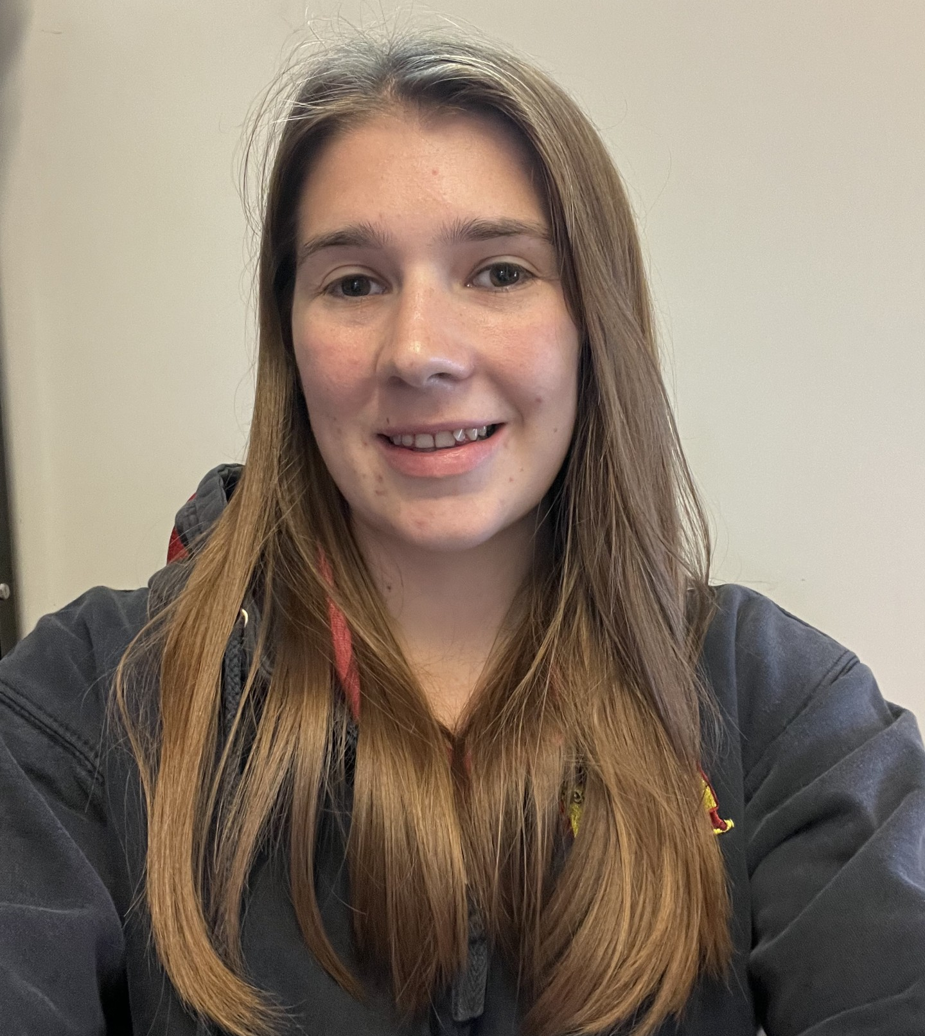 | - Bachelor of Arts with Honours in Early Childhood Studies (Level 6)  - Paediatric First Aid  - Level 3 SENCO Award  - Safeguarding Lead Practitioner  - Level 2 food safety
Mrs. Hollie Durrant  Deputy Manager | 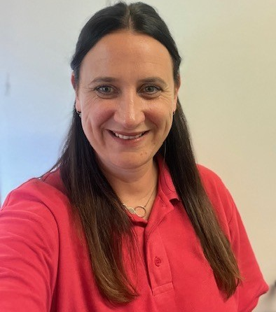 | - OU Working with Children in the Early Years (Level 4)  - SENCO  - Paediatric First Aid  - Safeguarding lead practitioner  - Emotional Literacy Support Assistant (ELSA)  - Elklan – Speech and Language Support  - Level 2 Food safety
Miss Julie East  Early Years Practitioner | 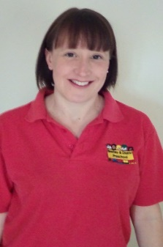 | - City & Guilds Early Years Childcare and Education (Level 3)  - Paediatric First Aid  - Safeguarding  - Special Educational Needs training  - Foundation Sign-along Tutor  - Level 2 food safety
Mrs. India Bonnett  Early Years Practitioner | 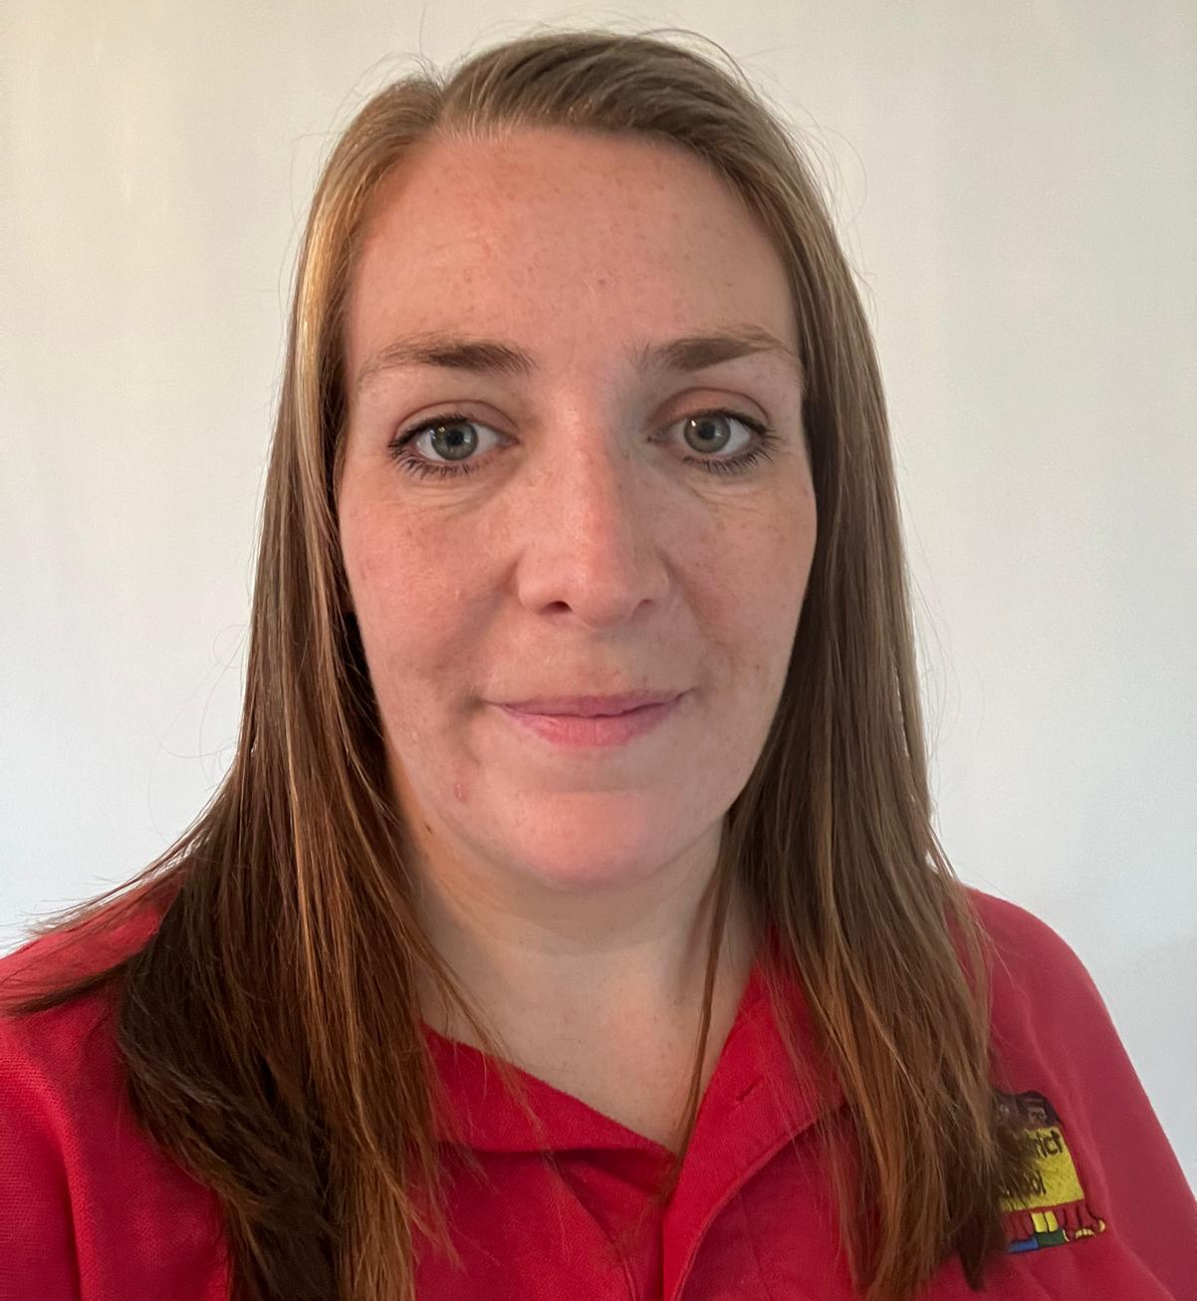 | - Level 3 Diploma for the Early Years  - Safeguarding  - Paediatric First aid  - Yoga and Mindfulness  - Level 2 food safety
Miss Kirstie Rayner  Early Years Practitioner | 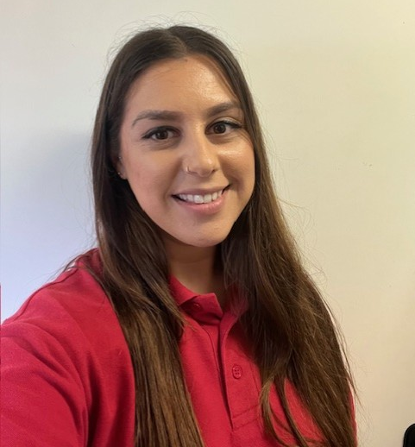 | - Level 3 BTEC National certificate in children’s care learning and development  - Introduction to Safeguarding  - Mini me yoga
Miss Lucy Tooke  Early Years Practitioner | 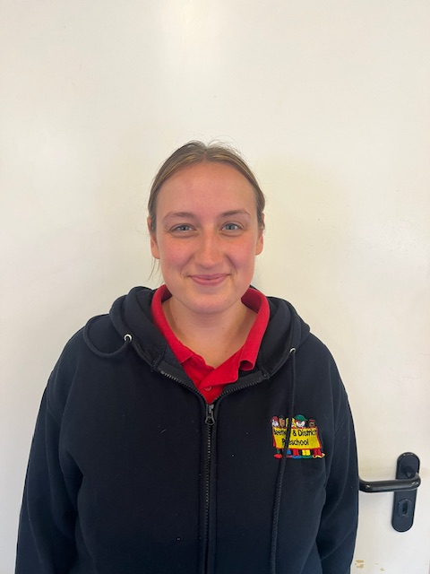 | - Level 3 Diploma for the Early years  - Safeguarding lead practitioner  - Food hygiene  - Paediatric first aid  - SENCO training
Mrs. Toni Tinker  Early Years Practitioner | 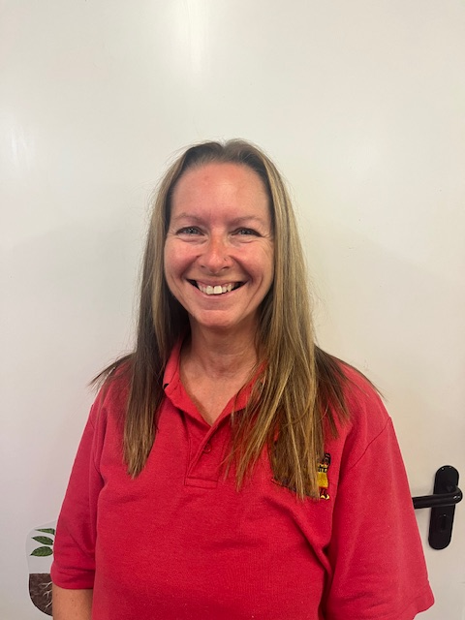 | - NVQ Level 3 in Playwork  - Paediatric First Aid
Miss Chloe Ott  Early Years Relief worker | 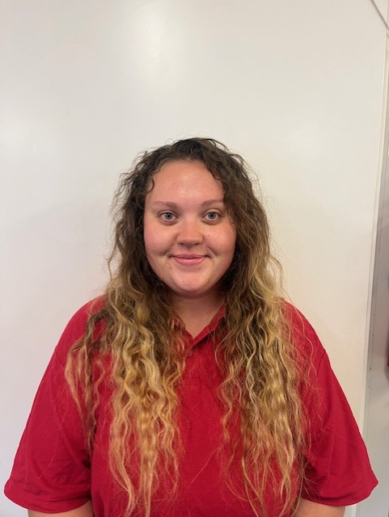 | - Skillsfirst Level 2 in Employment responsibilities and rights in Health, social care, children and young people’s settings  - Skillsfirst Level 2 certificate for children and young people’s workforce

COMMITTEE & OFSTED

Beetley Preschool, a member of the Early Years Alliance, is a community group owned and run by the parents of its children, together with paid staff. At the Annual General Meeting in the autumn term, a committee is elected to administer and be responsible for the organisation and policy of the group. Current committee members are listed on our website. All committee members are DBS checked for your children’s protection.

We are registered as a charity. We rely on fees, LEA funding, grants and fundraising to enable us to operate. The Preschool is registered with Ofsted who make regular inspections and issue a report. Please ask our manager, if you would like to look at the latest report or visit - https://reports.ofsted.gov.uk/.

ADMISSIONS
We are housed in a mobile building in the grounds of St Mary’s Primary School, Beetley, with whom we have close links.
We welcome children aged 2-5 Years, Monday-Friday 8.30am – 4pm (Term Time).
Daily we can accommodate 22 children maximum.
8 x 2-year-olds with a ratio of 1-4 adults and 14 x 3–5-year-olds with a ratio of 1-8 adults.
To join our waiting list or to confirm your space we require a completed registration form with a £10 deposit which is refunded once your child has been attending the preschool for 6 weeks.

FEES & FUNDING
2 Years Old’s ...........…. £5.66 per hour
3-5 Year Old’s …...........£5.34 per hour
Our consumables rate is charged at 75p per half day (Morning or afternoon session) and £1.50 per full day. For more information please see our fees and charges policy.
Universal funding is available from the term following a child's 3rd birthday up until they reach compulsory school age, for every child, irrespective of background or family circumstances. 30 hours funding is available at the same time as the universal funding if you meet the criteria.
Eligible 2-year-olds, receive funding the term after their 2nd birthday.
To check eligibility for 2-year-old and 30-hour funding, go to https://www.childcarechoices.gov.uk.
We invoice half termly via our Famly app.

SETTLING IN
We want children to feel safe, happy and secure in the absence of their parents/carers.
We will work with you and the child’s needs to support and provide the best settling in process for each individual child.
We encourage, where appropriate to separate from your child for brief periods at first, gradually building up to longer absences.

CLOTHES & BAGS
Old clothes are best for preschool as glue and paint have a habit of finding their way onto clothes. A spare change of clothes is also needed.
Sun hats must be worn in the summer when in direct sun and parents/carers should provide a bottle of sun cream (named) for staff to reapply on longer sessions.
The children are encouraged to be as independent as possible, taking themselves to the toilet, putting on their own shoes and coats, help is given if it is needed. However, to make it easier for them, it is helpful if they are dressed in clothes and shoes which they can manage for themselves.
We access the outside in all weathers unless deemed dangerous so wellies, hats, waterproof coats/trousers and gloves are needed.
Sweatshirts and polo shirts with our distinctive logo are available to purchase but are not compulsory. Please ask for further details.
A small named rucksack is ideal for carrying all these items. Please ensure all items are clearly named.

TOILETING/NAPPIES
We have low level toilets, washbasins and a nappy changing unit with built in steps for the children’s use. They are encouraged to wash their hands after using the toilet or having a nappy change. Please provide a small named towel (face cloth) with a hanging loop for hand drying.

Nappy changing or assistance in the toilet will only be done by a member of staff who has had a DBS check and they will inform another member of staff before doing so. The nappy will be changed on the unit in the disabled toilet with the door jammer fitted, leaving the door slightly open. Adults will wear fresh disposable gloves and aprons.

FOOD
Beetley Preschool promotes healthy eating. We provide healthy choices at snack times in the morning and afternoon.

We encourage healthy choices for packed lunches, asking parents/carers to consider what they put in their child's lunchbox to offer a balanced diet. Parents/carers can order and pay for a lunch from the primary school kitchen if they prefer. Find out more about lunches in our leaflet.
This setting is a 'NO NUTS' provision.

FUNDRAISING

Fundraising is an important part of our income to enable us to operate. Our friendly dedicated committee work hard to organise many events over the year. Events will be advertised in our newsletter, Facebook page, Famly app, website or notice boards.

Please support where you can. You do not have to be a committee member to help at our events. Please speak to the supervisor to join the general/fundraising committee or if you feel you could offer some occasional help.

POLICIES AND PROCEDURES
Beetley and District Preschool operates in accordance with a number of policies and procedures which have been drawn up by the committee and approved by Norfolk County Council and Ofsted. The committee and staff review the policies regularly, any changes in legislation, circumstances, or improvements to working practices are incorporated and the necessary amendments made.
A copy is available for your inspection at the preschool. Some are also available on our website – http://www.beetley-preschool.org/

ARRIVAL AND COLLECTION
A member of staff records arrival and collection of all children on the Famly app and in the paper register. Staff ensure your child goes only with the authorised person/s. If someone else will be collecting your child, please let us know. A password will be required for the person collecting if they are unknown to us.

NON-ARRIVAL OF PARENT/CARER TO COLLECT CHILD
If a child is not collected, the parent/carer will be contacted and staff will wait with the child until they arrive. In the event of being unable to contact the parent/carer, the child will be taken care of by 2 members of staff, on the preschool premises, who will continue to try emergency and other telephone numbers supplied. If they are unable to make contact with parent/carer or authorised persons within two hours, Children's Services will be contacted.

RECORDING INJURIES THAT HAVE OCCURRED OUTSIDE PRESCHOOL.
At times where children arrive at preschool with injuries, i.e., bruises, abrasions etc. We will record the details on a log sheet in the presence of the parent who will sign the sheet. These will be kept in the locked filing cabinet in the office.

SEVERE WEATHER
In the event of severe weather, e.g., Snow and floods, Beetley and District Preschool will abide by the decision made by the head of St Mary's School as to whether the school, and therefore preschool, will be closed. We will notify you using the Famly app should we need to close the preschool unexpectedly or please listen to Radio Norfolk for clarification or check the School Closures website, linked on our website, beetley-preschool.org

IDENTIFICATION OF ILLNESSES, WHICH JUSTIFY EXCLUSION FROM THE FACILITY

Extract from policy
- Parents will be encouraged to keep children away from Preschool if they have any minor illnesses. Children who are obviously not well or have been ill during the previous night should not be accepted to attend.
- If a child becomes ill during the session, parents should be contacted as soon as possible and the child kept under strict supervision and made as comfortable as possible. Other children in the group should be protected from any infection.
- With regard to specific communicable diseases, the document 'Guidance for Schools on Communicable Disease Matters' (as displayed in the Preschool) will be consulted and action taken accordingly.
- Chickenpox, The Health Protection Agency recommends that children should stay away from school/preschool until all vesicles have crusted over.
The exclusion period for Gastroenteritis is 48 hours after symptoms stop.
HEADLICE
Preschool recommends that parents check their child's hair on a regular basis, ideally once a week. Should headlice be detected treatment is recommended. If we are advised that any child has headlice, all parent/carers will be notified that a check would be advisable. Current leaflets giving advice on detection and treatment are available from Preschool.

USEFUL TELEPHONE NUMBERS

MANAGER - Miss Abigail Jenkins 01362 860860 or 07736405862
CHAIRPERSON - Mrs. Laura Cross 01362 860860
EARLY YEARS ALLIANCE 01603 767525
Norfolk Family Information Service 0344 8008020
OFSTED 0300 1231231

WHERE TO FIND US

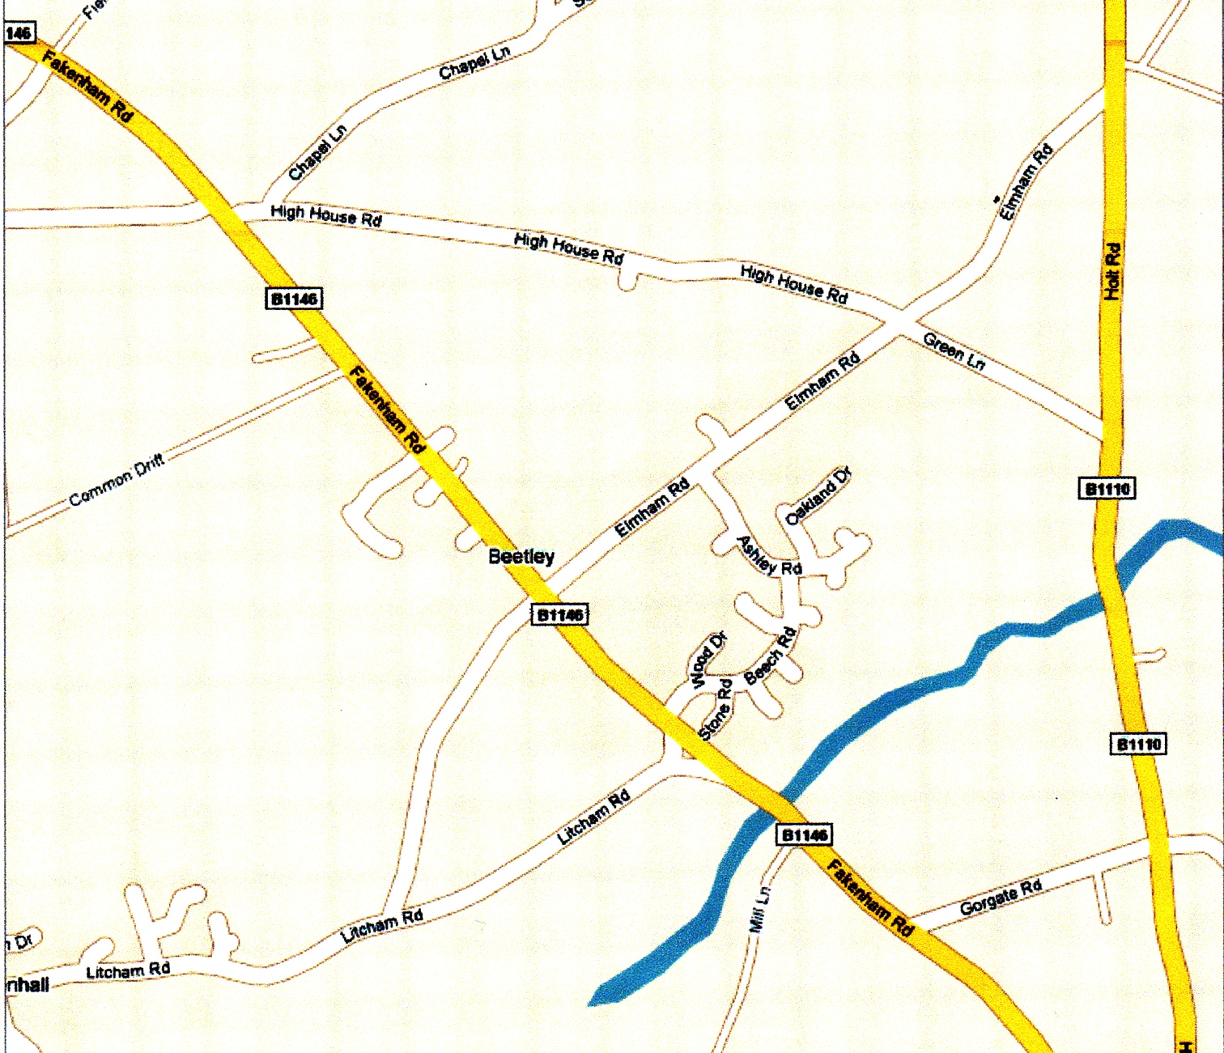

The Mobile
St Mary’s CP School
Elmham RD
Beetley
Dereham
NR20 4BW

We hope you decide to join our preschool community.
If you require any further information, please let us know.

